CSC 235, Introduction to Linux &

Linux Administration

Fall 2023

**Assignment #2: Linux CLI**

**Due: Sunday, September 3, 2023 (NLT 23:59)**

**Instructions:**

1. Insert your answers into this document (*text and screenshots*)
2. Highlight your answers in green (*text only*)
3. When finished, rename the document (*please use the naming convention below*)
4. Upload the renamed document to the Moodle assignment

**A2 - last name, first name.docx** (e.g., **A2 - Nonnweiler, Joel**)

**Exercise I**

1. Open Linux and type the command that provides you with your current location.

2. At the prompt, type the command that creates a subdirectory of your current directory named *Sales*. Confirm that the directory has been created and display your answer.

**Answer:**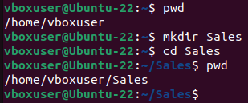

3. Type the command that changes your current location in the file system to the *Sales* subdirectory. Confirm that you are in the *Sales* subdirectory.

**Answer: **

4. Create a new file named *Sales.date* in the *Sales* subdirectory by directing the output of the Date utility to the file. Verify that the Sales.date file exists in the subdirectory. Append the *Sales.date* file with the current date, first, print output to the screen; next append the 2023 calendar to *Sales.date*. Provide screenshots of both using the cat command.

5. Go back to your home directory – verify the change occurred.

**Answer:**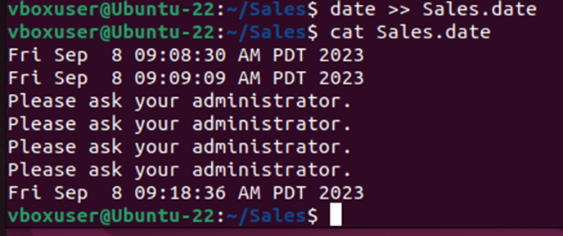

**Exercise II**

1. Create the following files in your home directory with the following content:

**Filename File Content**

*Car_insurance* All current online users

*Travel_insurance* Current date

*House_insurance* September 2022 calendar

*Life_insurance* List of all files in the current directory

*Health_insurance* List of all processes associated with your login account

*\*Hint: type the correct commands that create the above files with the appropriate content*

**Answer:** (*show the associated commands and file contents*.)

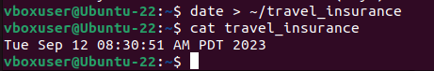

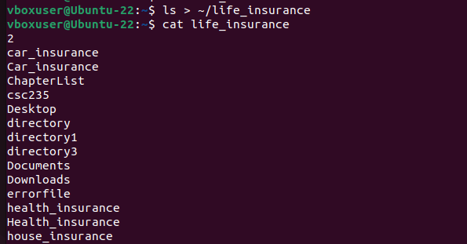

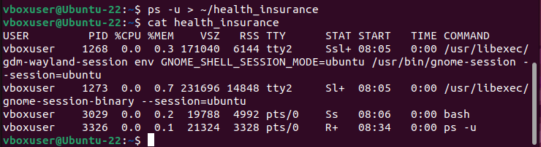

2. Copy the *Car_insurance* file to the Sales subdirectory that you created above. Next, rename the *House_insurance* file to *House*

3. Remove the *Health_insurance* file with a confirmation. What is the argument used to prompt for a confirmation?

**Answer:**

4. Attempt to print the *Life_insurance* file to a printer that you specify. (*Note: sending a file to a printer is not covered in the first two sections of TestOut. Check out man -k print*). What command did you use? What message did you receive?

**Answer: cle**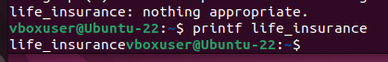

**Exercise III – Employing Powerful Utilities**

1. Create the following chapter files of your sci-fi book you are writing in your home directory with the content provided:

Chapter_1 It was a dark and stormy night.

Robbie unsuccessfully tried to block out the sounds of the thunderstorm so that Gloria would not wake up.

Chapter_2 Robbie looked at his watch.

It was too late.

Chapter_3 The sun was setting but Powell didn’t care.

**Answer:**

Next, verify that all files were created in your home directory. For each chapter, verify the line, word, and character count.

2. Create a file in your home directory named *ChapterList* that lists the names of the first three chapters in your home directory. Sort the file in reverse order and display the results.

**Answer:**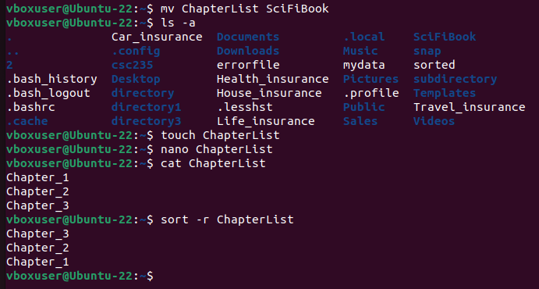

3. Locate the word *thunderstorm* in the appropriate chapter by employing the correct utility command at your terminal home directory. Locate the word *storm*. Do your results differ? Why or why not. Display your command and output.

**Answer: The results do differ. When you search “storm” alone it pulls up another line where it was used without “thunder before it” as well.**

4. You want to check how the chapters flow together; create a file named *my_scifi* that is a concatenation of the three chapter files. Display the contents of *my_scifi* on your screen to show it contains the text of all three files.

**Answer:**